**Experiment 11 & 12**

**Name: Shubham Mourya SAP ID: 60017230110**

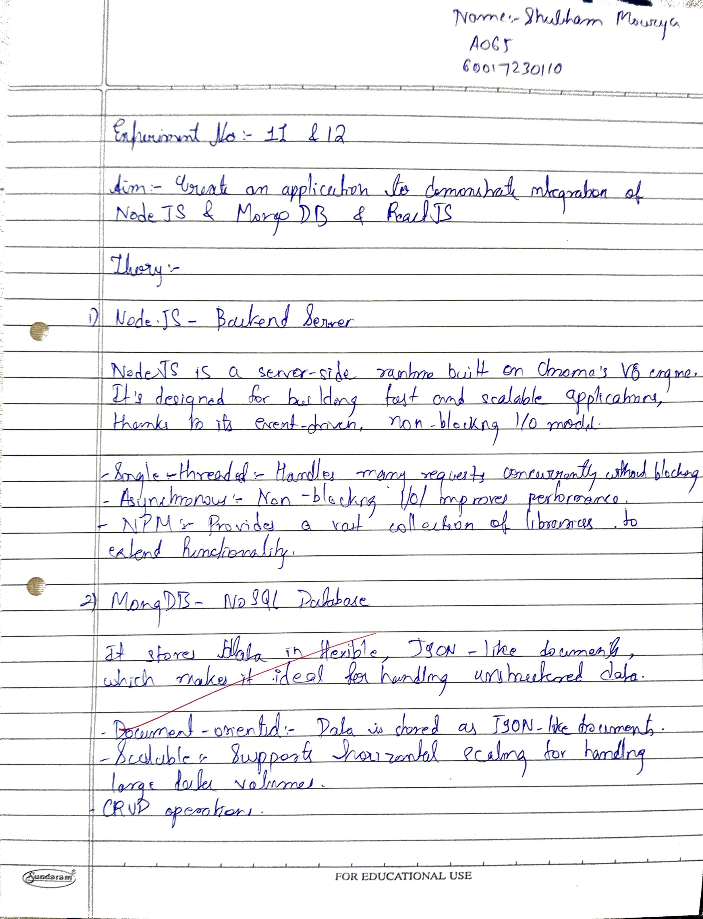

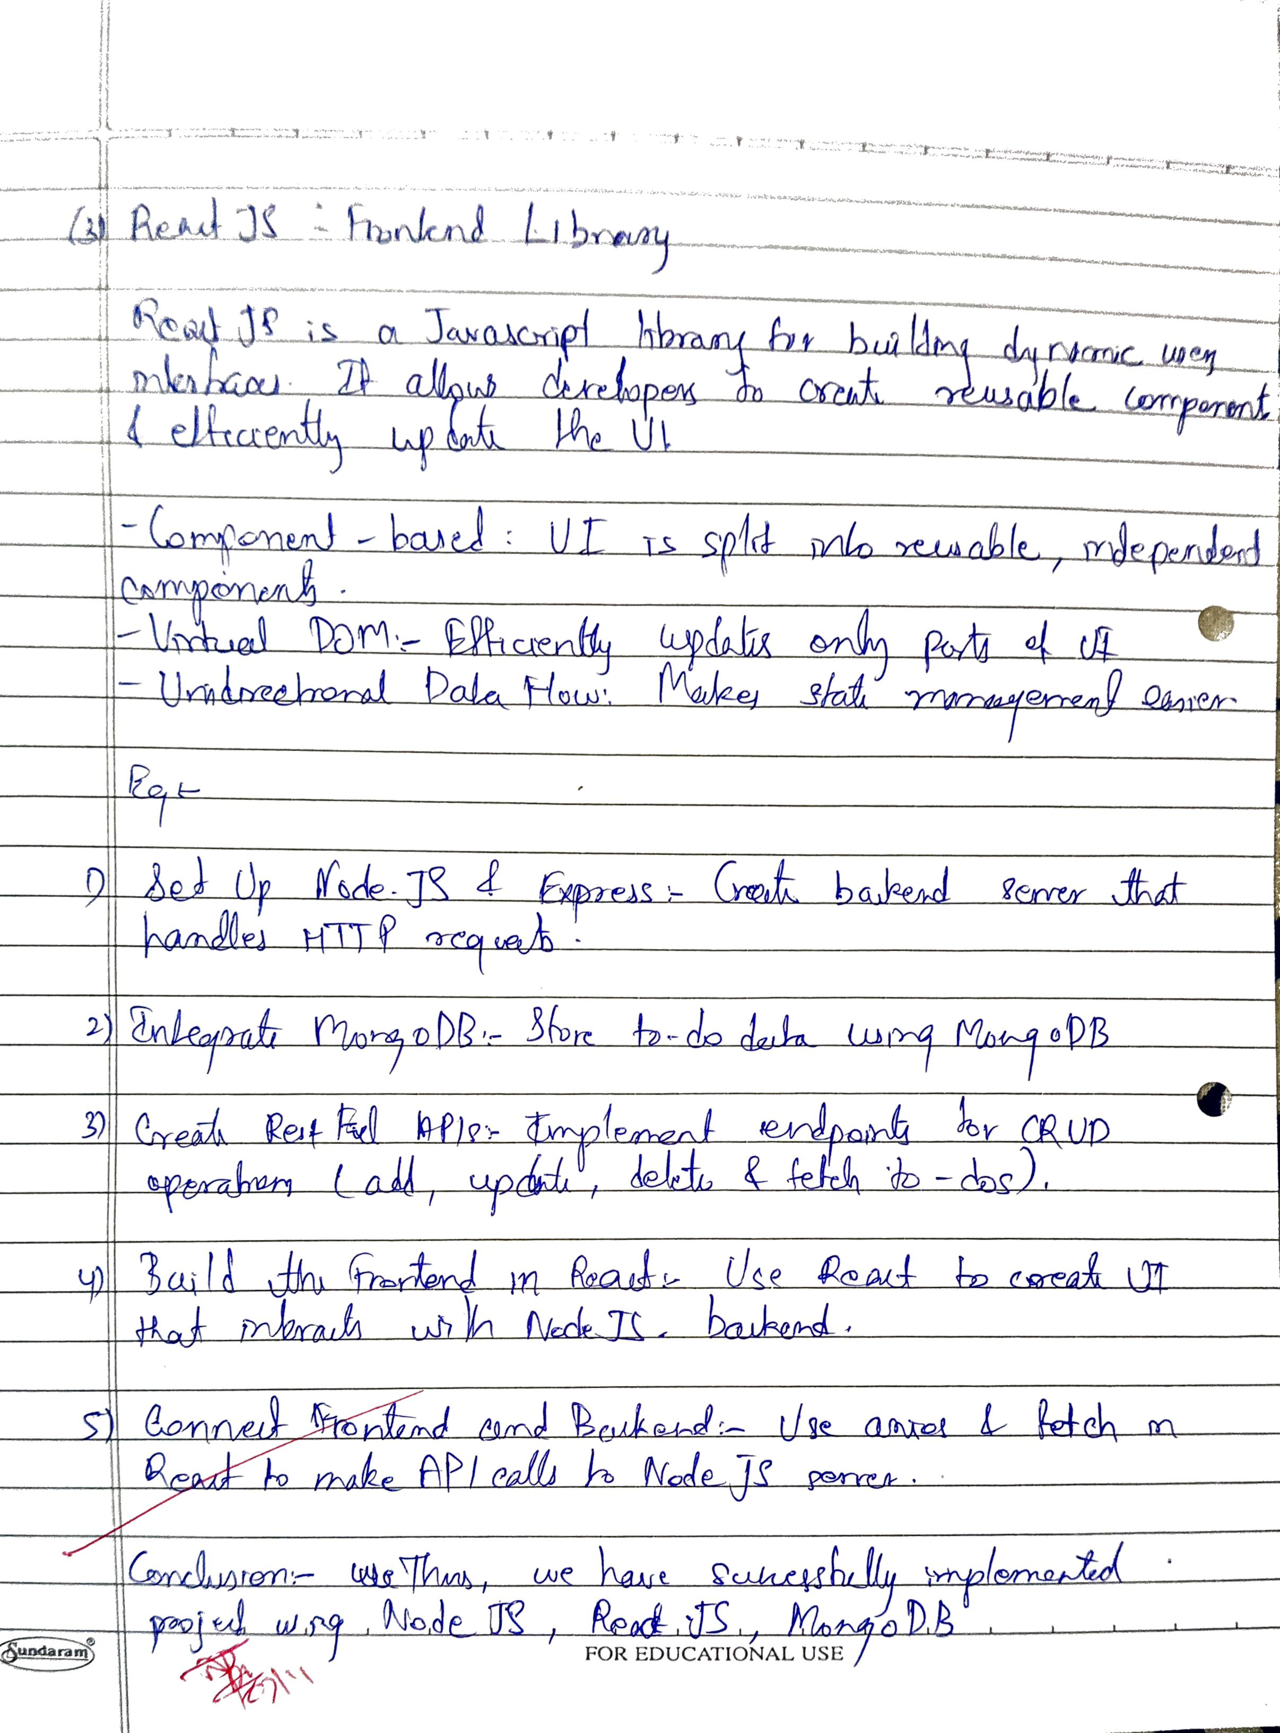

|  |  |
| --- | --- |
| Aim | **Create an application to demonstrate integration of Node JS and MongoDB and React JS** |
| Software | VS Code |
| Pre-requisite | Active internet connection |
| Code | **Frontend**  **Components->Note.jsx**  import React from 'react';  function Note({ note, onDelete, onEdit }) {    return (      <div className="bg-white p-5 rounded-lg shadow-md hover:shadow-lg transition-shadow duration-300">        <h2 className="text-xl font-semibold text-gray-800 mb-3">{note.title}</h2>        <p className="text-gray-600 mb-4 line-clamp-3">{note.description}</p>        <div className="flex items-center justify-between">          <span className="px-3 py-1 bg-blue-100 text-blue-600 text-sm rounded-full">{note.tag}</span>          <div className="flex gap-2">            <span className="text-sm text-gray-400">{new Date(note.date).toLocaleDateString()}</span>            <button onClick={() => onEdit(note)} className="text-blue-500 hover:text-blue-700">              Edit            </button>            <button onClick={() => onDelete(note._id)} className="text-red-500 hover:text-red-700">              Delete            </button>          </div>        </div>      </div>    );  }  export default Note;  **NoteForm.jsx**  import React, { useState, useEffect } from 'react';  function NoteForm({ onAddNote, onUpdateNote, currentNote }) {    const [title, setTitle] = useState('');    const [description, setDescription] = useState('');    const [tag, setTag] = useState('General');    useEffect(() => {      if (currentNote) {        setTitle(currentNote.title);        setDescription(currentNote.description);        setTag(currentNote.tag);      }    }, [currentNote]);    const handleSubmit = (e) => {      e.preventDefault();      const note = { title, description, tag };      if (currentNote) {        onUpdateNote({ ...note, _id: currentNote._id });      } else {        onAddNote(note);      }      resetForm();    };    const resetForm = () => {      setTitle('');      setDescription('');      setTag('General');    };    return (      <form onSubmit={handleSubmit} className="space-y-4">        <div>          <input            type="text"            value={title}            onChange={(e) => setTitle(e.target.value)}            placeholder="Note Title"            className="w-full px-4 py-2 border border-gray-300 rounded-lg focus:ring-2 focus:ring-blue-500 focus:border-transparent"            required          />        </div>        <div>          <textarea            value={description}            onChange={(e) => setDescription(e.target.value)}            placeholder="Note Description"            rows="4"            className="w-full px-4 py-2 border border-gray-300 rounded-lg focus:ring-2 focus:ring-blue-500 focus:border-transparent"            required          />        </div>        <div>          <input            type="text"            value={tag}            onChange={(e) => setTag(e.target.value)}            placeholder="Tag (Optional)"            className="w-full px-4 py-2 border border-gray-300 rounded-lg focus:ring-2 focus:ring-blue-500 focus:border-transparent"          />        </div>        <button          type="submit"          className="w-full bg-blue-500 text-white py-2 px-4 rounded-lg hover:bg-blue-600 transition-colors duration-300"        >          {currentNote ? 'Update Note' : 'Add Note'}        </button>      </form>    );  }  export default NoteForm;  **services->NoteService.js**  const API_URL = 'http://localhost:5000/api/notes';  const getNotes = async () => {    const response = await fetch(`${API_URL}/fetchallnotes`);    return await response.json();  };  const addNote = async (note) => {    const response = await fetch(`${API_URL}/addnote`, {      method: 'POST',      headers: { 'Content-Type': 'application/json' },      body: JSON.stringify(note),    });    return await response.json();  };  const updateNote = async (note) => {    const response = await fetch(`${API_URL}/updatenote/${note._id}`, {      method: 'PUT',      headers: { 'Content-Type': 'application/json' },      body: JSON.stringify(note),    });    return await response.json();  };  const deleteNote = async (id) => {    await fetch(`${API_URL}/deletenote/${id}`, { method: 'DELETE' });  };  export default { getNotes, addNote, updateNote, deleteNote };  **App.jsx**  import React, { useState, useEffect } from 'react';  import Note from './components/Note';  import NoteForm from './components/NoteForm';  import NoteService from './services/NoteService';  function App() {    const [notes, setNotes] = useState([]);    const [loading, setLoading] = useState(true);    const [currentNote, setCurrentNote] = useState(null);    useEffect(() => {      fetchNotes();    }, []);    const fetchNotes = async () => {      try {        setLoading(true);        const data = await NoteService.getNotes();        setNotes(data);      } catch (error) {        console.error('Error fetching notes:', error);      } finally {        setLoading(false);      }    };    const addNote = async (newNote) => {      try {        const savedNote = await NoteService.addNote(newNote);        setNotes([...notes, savedNote]);      } catch (error) {        console.error('Error adding note:', error);      }    };    const updateNote = async (updatedNote) => {      try {        const savedNote = await NoteService.updateNote(updatedNote);        setNotes(notes.map(note => note._id === savedNote._id ? savedNote : note));        setCurrentNote(null);      } catch (error) {        console.error('Error updating note:', error);      }    };    const deleteNote = async (id) => {      try {        await NoteService.deleteNote(id);        setNotes(notes.filter(note => note._id !== id));      } catch (error) {        console.error('Error deleting note:', error);      }    };    return (      <div className="min-h-screen bg-gradient-to-br from-gray-50 to-gray-100 p-6">        <div className="max-w-4xl mx-auto">          <h1 className="text-4xl font-bold text-center text-gray-800 mb-8">✍️ Notes App</h1>          <div className="bg-white rounded-xl shadow-lg p-6 mb-6">            <NoteForm onAddNote={addNote} onUpdateNote={updateNote} currentNote={currentNote} />          </div>          {loading ? (            <div className="text-center py-4">Loading...</div>          ) : (            <div className="grid gap-4 md:grid-cols-2">              {notes.map(note => (                <Note                  key={note._id}                  note={note}                  onDelete={deleteNote}                  onEdit={() => setCurrentNote(note)}                />              ))}            </div>          )}        </div>      </div>    );  }  export default App;  **Backend**  **Models->Note.js**  const mongoose = require('mongoose');  const Schema = mongoose.Schema;  const NoteSchema = new Schema({      title: {          type: String,          required: true      },      description: {          type: String,          required: true      },      tag: {          type: String,          default: "General"      },      date: {          type: Date,          default: Date.now      }  });  module.exports = mongoose.model('Note', NoteSchema);  routes->notes.js  const express = require('express');  const router = express.Router();  const Note = require('../models/Note');  const { body, validationResult } = require('express-validator');  // ROUTE 1: Get all notes using: GET "/api/notes/fetchallnotes"  router.get('/fetchallnotes', async (req, res) => {      try {          const notes = await Note.find();          res.json(notes);      } catch (error) {          console.error(error.message);          res.status(500).send("Internal Server Error");      }  });  // ROUTE 2: Add a new note using: POST "/api/notes/addnote"  router.post('/addnote', [      body('title', 'Enter a valid title').isLength({ min: 3 }),      body('description', 'Description must be at least 5 characters').isLength({ min: 5 }),  ], async (req, res) => {      try {          const { title, description, tag } = req.body;          // If there are validation errors, return Bad request and the errors          const errors = validationResult(req);          if (!errors.isEmpty()) {              return res.status(400).json({ errors: errors.array() });          }          const note = new Note({              title, description, tag          });          const savedNote = await note.save();          res.json(savedNote);      } catch (error) {          console.error(error.message);          res.status(500).send("Internal Server Error");      }  });  // ROUTE 3: Update an existing note using: PUT "/api/notes/updatenote/:id"  router.put('/updatenote/:id', async (req, res) => {      const { title, description, tag } = req.body;      try {          // Create a newNote object          const newNote = {};          if (title) { newNote.title = title; }          if (description) { newNote.description = description; }          if (tag) { newNote.tag = tag; }          // Find the note to be updated and update it          let note = await Note.findById(req.params.id);          if (!note) { return res.status(404).send("Not Found"); }          note = await Note.findByIdAndUpdate(req.params.id, { $set: newNote }, { new: true });          res.json(note);      } catch (error) {          console.error(error.message);          res.status(500).send("Internal Server Error");      }  });  // ROUTE 4: Delete an existing note using: DELETE "/api/notes/deletenote/:id"  router.delete('/deletenote/:id', async (req, res) => {      try {          // Find the note to be deleted and delete it          let note = await Note.findById(req.params.id);          if (!note) { return res.status(404).send("Not Found"); }          note = await Note.findByIdAndDelete(req.params.id);          res.json({ "Success": "Note has been deleted", note });      } catch (error) {          console.error(error.message);          res.status(500).send("Internal Server Error");      }  });  module.exports = router;  **db.js**  const mongoose = require('mongoose');  const MONGOURI = "mongodb://localhost:27017/notesapp";  const connectToMongo = () => {      mongoose.connect(MONGOURI).then(() => {          console.log("Connected to MongoDB successfully");      }).catch((err) => {          console.error("Error connecting to MongoDB: ", err);      });  };  module.exports = connectToMongo;  **index.js**  const connectToMongo = require('./db');  const express = require('express');  const cors = require('cors');  // Connect to MongoDB  connectToMongo();  const app = express();  const port = 5000;  // Middleware  app.use(cors());  app.use(express.json());  // Routes  app.use('/api/notes', require('./routes/notes'));  app.listen(port, () => {      console.log(`Notes app backend running on port ${port}`);  }); |
| Result |  |
| Conclusion | Thus, we have successfully performed the integration of Node.js, MongoDB, and React.js to create a full-stack notes application. The frontend allows users to add, edit, and delete notes with real-time updates, while the backend handles data persistence and validation through RESTful APIs connected to MongoDB. This experiment demonstrates the seamless communication between the frontend and backend, showcasing CRUD operations in a practical web application. |